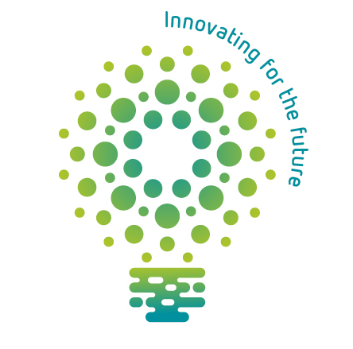

|  |
| --- |
| Name: |
| Class: |

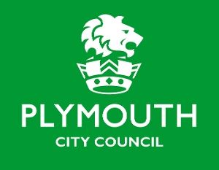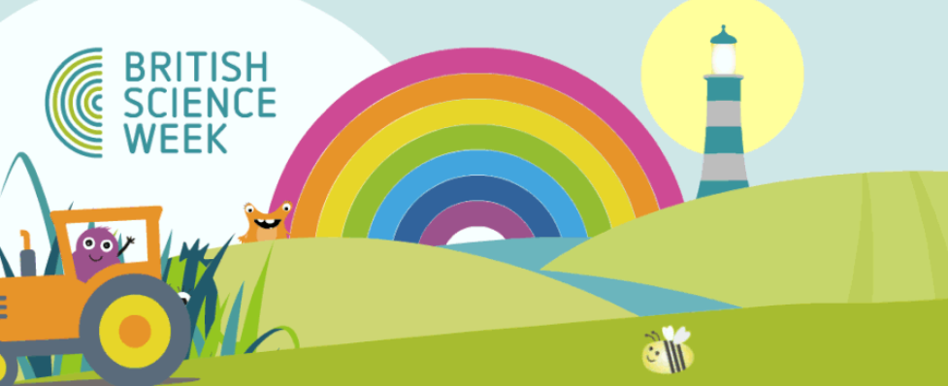

Science Week Skills Passport

Curious Curious Curious

Resilient Resilient Resilient

Creative Creative Creative

Observant Observant Observant

Teamwork Teamwork Teamwork

Hardworking Hardworking Hardworking

Organised Organised Organised

Patient Patient Patient

Leadership Leadership Leadership

Problem Solving Problem Solving

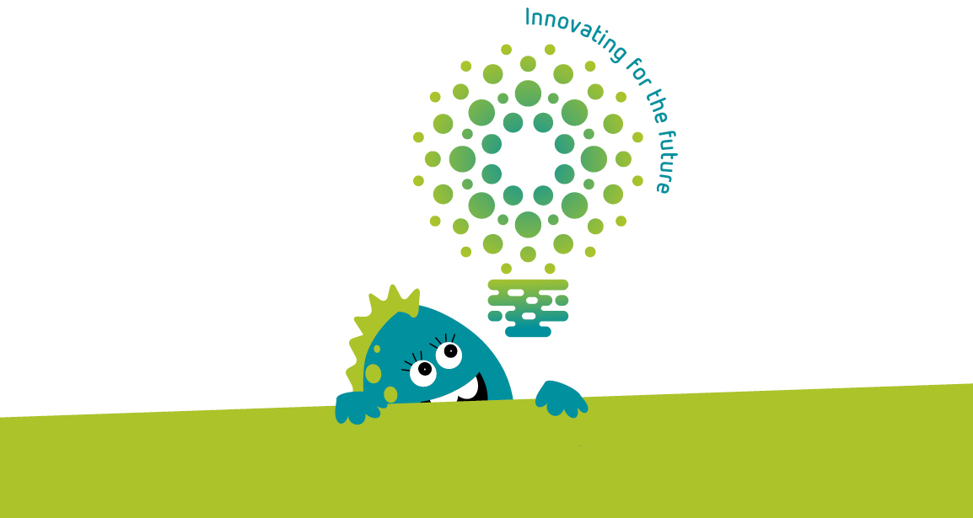

IT Skills IT Skills IT Skills IT Skills

Motivated Motivated Motivated

**‘Innovation is seeing what everybody has seen and thinking what nobody has thought’**

Dr. Albert Szent Gyorgi – Discovered Vitamin C

**We’re looking for scientists who can demonstrate at least 10 of these 12 skills.**

**If you’ve achieved this scientific feat, return your passport to your teacher for your British Science Week 2021 Certificate.**