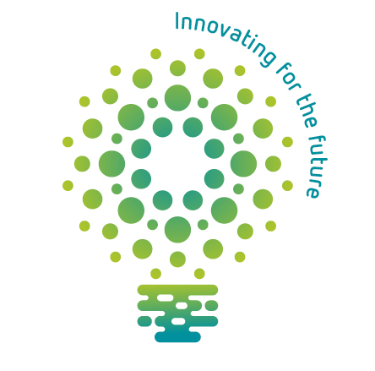
Name:
Class:
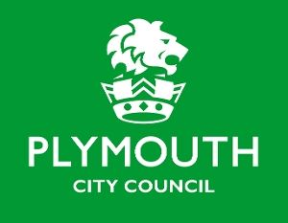
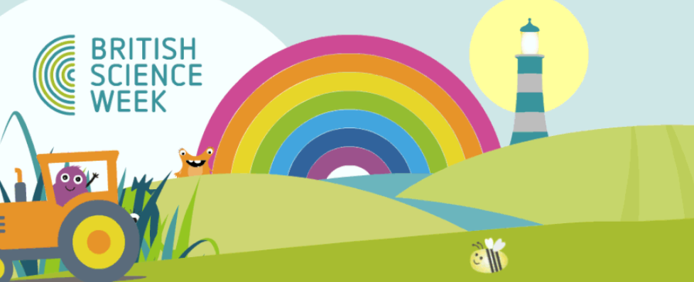
Science Week Skills Passport
Curious Curious Curious
Resilient Resilient Resilient
Creative Creative Creative
Observant Observant Observant
Teamwork Teamwork Teamwork
Hardworking Hardworking Hardworking
Organised Organised Organised
Patient Patient Patient

Leadership Leadership Leadership
Problem Solving Problem Solving

IT Skills IT Skills IT Skills IT Skills
Motivated Motivated Motivated

Document how you have demonstrated the above skills.
Skills | How I have demonstrated this skill
e.g. Team work | I led my team to ensure that everyone was included.
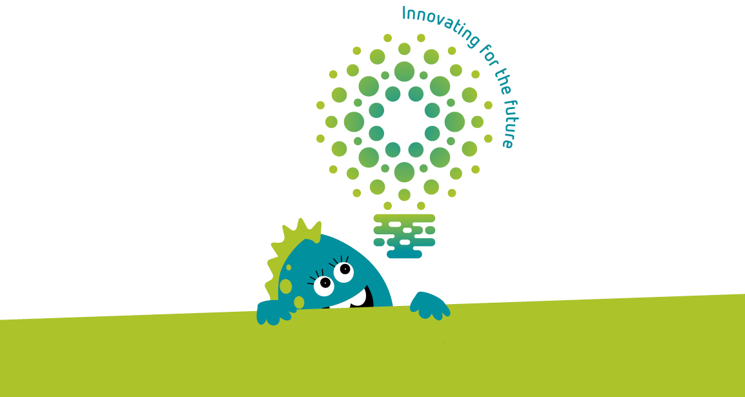
‘Innovation is seeing what everybody has seen and thinking what nobody has thought’
Dr. Albert Szent Gyorgi – Discovered Vitamin C
We’re looking for scientists who can demonstrate at least 10 of these 12 skills.

If you’ve achieved this scientific feat, return your passport to your teacher for your British Science Week 2021 Certificate.

